

*AI 407 – Introduction to Robotics*

**Lab 6 Manual**

**OpenManipulator-X Programming and Control**

* **Lab objectives**
* **OpenManipulator-X Robot Overview**
* **Environment Setup & Data Structure Understanding**
* **Controlling OpenManipulator: Teleoperation & Python Scripting**
* **Lab Requirements**
* **Software:** Ubuntu 22.04 LTS, ROS 2 Humble
* **Hardware:** Students should work on Lab Devices
* **Before You Start**

Kindly read the manual, review the references if any, before beginning implementation.

* **Introduction to OpenManipulator-X**

The OpenManipulator-X is a compact and lightweight robotic arm designed for research, education, and prototyping. Fully compatible with ROS 2, it enables precise control for tasks like pick-and-place, trajectory planning, and object manipulation. It features four revolute joints and a gripper, powered by DYNAMIXEL smart actuators, ensuring smooth and accurate motion. The robot supports Gazebo simulation, MoveIt!, and Python scripting, making it ideal for learning forward/inverse kinematics and trajectory control.

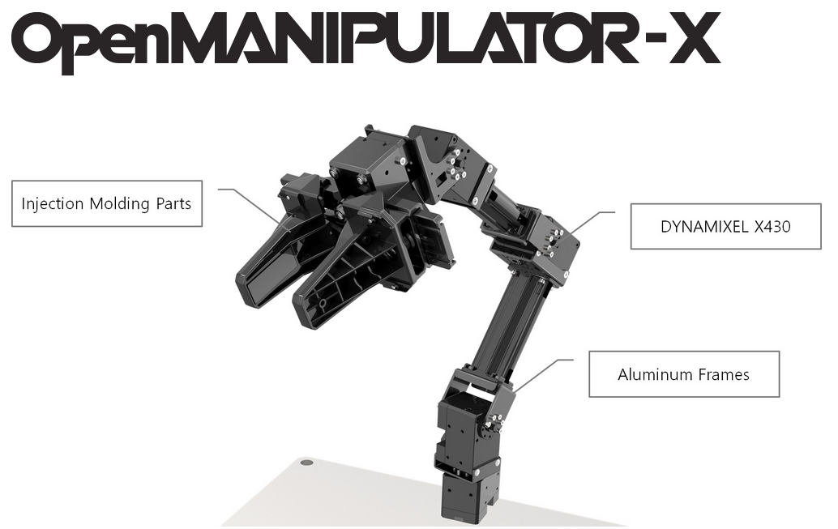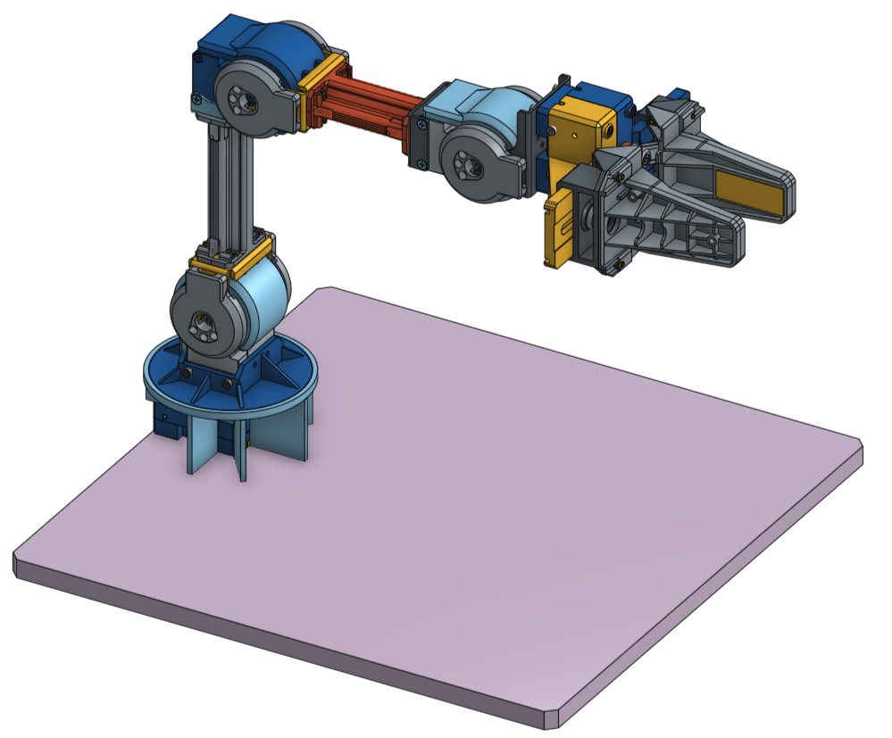

**The significance of each joint in the OpenManipulator-X:**

* Base Joint (Joint 1): Rotates the entire manipulator around the vertical axis, allowing for horizontal positioning of the gripper. This provides movement along a circular path.
* Shoulder Joint (Joint 2): Moves the arm forward and backward in the horizontal plane, affecting the reach of the gripper in the x-axis direction.
* Elbow Joint (Joint 3): Controls the vertical movement of the lower arm, allowing the gripper to move up and down in the y-axis direction. This also helps in adjusting the reach of the manipulator.
* Wrist Joint (Joint 4): Rotates the gripper, which affects its orientation (pitch, yaw, roll), but it doesn't affect its overall position.

Each joint's movement changes the gripper's pose (its position and orientation in space), which is essential for tasks like picking up objects, where precise control over the gripper's pose is required.

* **Exercise 1: Setting Up OpenManipulator-X in Gazebo**

**Step 1: Install dependent packages for OpenMANIPULATOR-X. Follow this documentation:**

<https://emanual.robotis.com/docs/en/platform/openmanipulator_x/quick_start_guide/#setup>

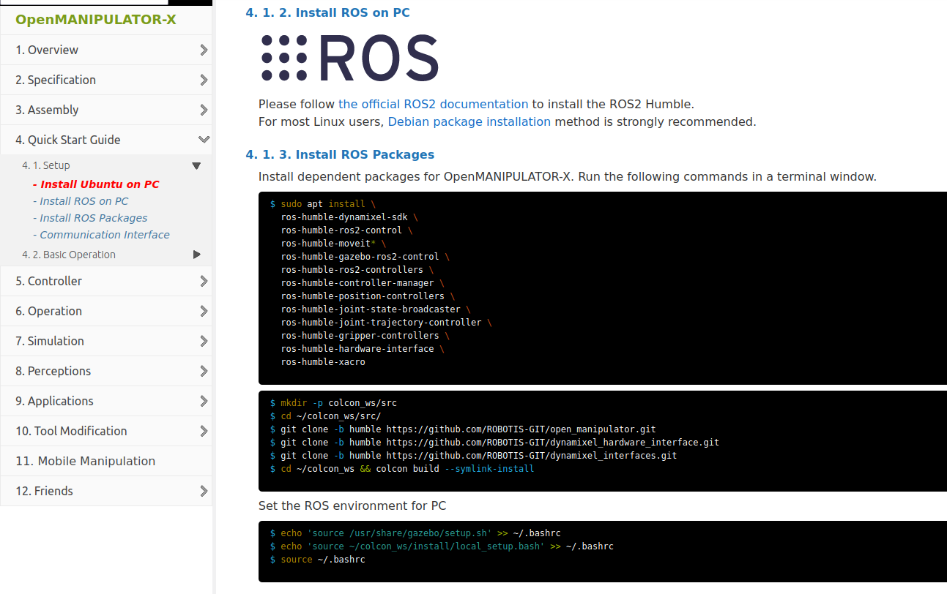Make sure to source this workspace in the .bashrc file. To do that open a new terminal and write the command

***gedit .bashrc***

Once the file open go and add the following at the end:

**source /usr/share/gazebo/setup.sh**

**source ~/colcon_ws/install/local_setup.bash**

**Step 2: Launch OpenManipulator-X with Gazebo (Terminal #1)**

***ros2 launch open_manipulator_x_bringup gazebo.launch.py***

**Step 3: Launch the MoveIt Servo Node (Terminal #2)**

Open a terminal and execute the servo launch file below; MoveIt Servo provides real-time, smooth, and responsive control for robotic manipulators in joint.

***ros2 launch open_manipulator_x_moveit_config servo.launch.py***

**Step 4: Teleoperate the Robot Using Keyboard controller (Terminal #3)**

***ros2 run open_manipulator_x_teleop open_manipulator_x_teleop***

**Step 5: Investigate Gazebo Topic (Terminal #4)**

***ros2 topic list***

***ros2 topic echo /arm_controller/joint_trajectory***

**Step 6: Adjust the Robot’s Position**

Use the keyboard controls to move the robot into the desired position.

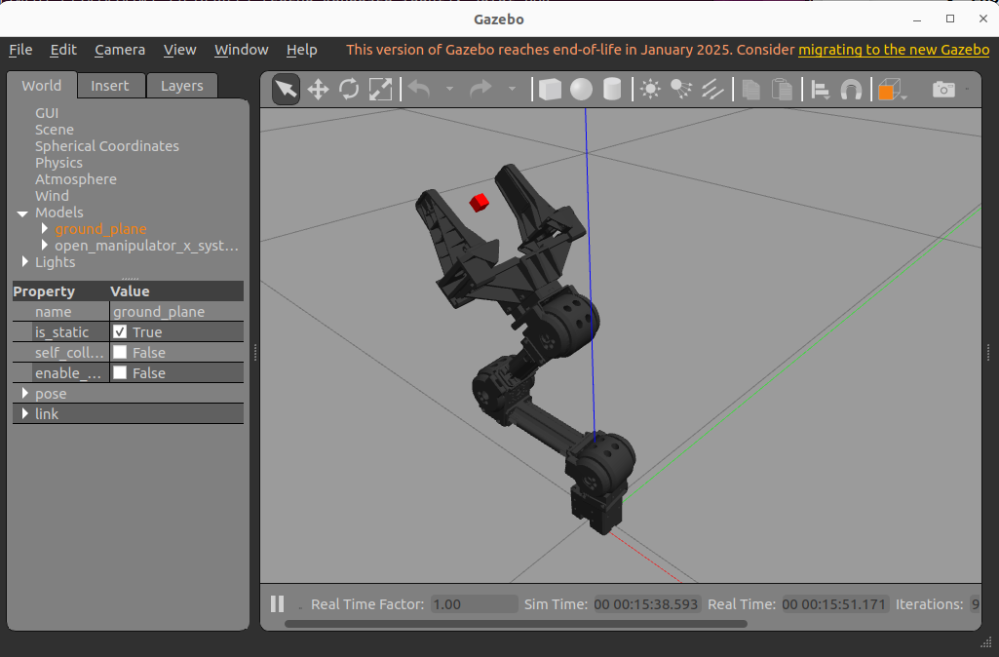

**Put screenshots of your work here (for ALL the steps):**

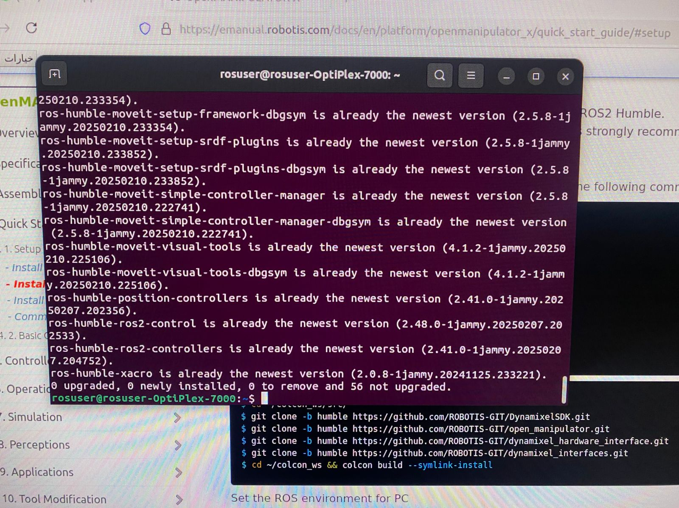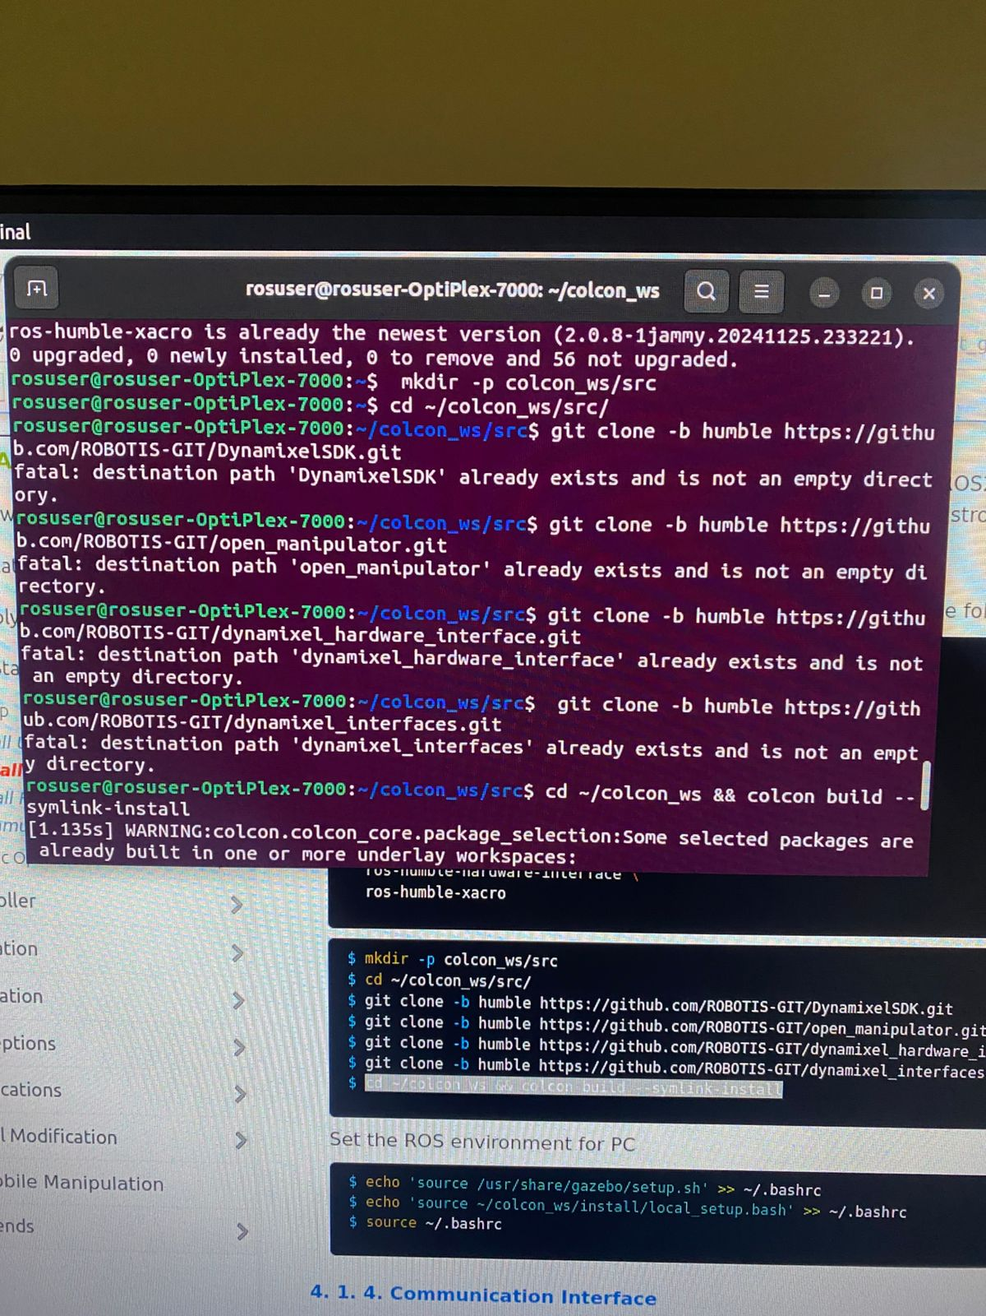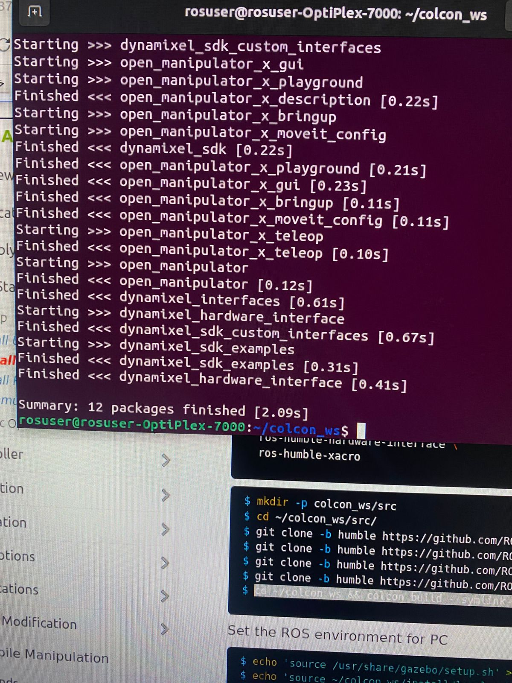

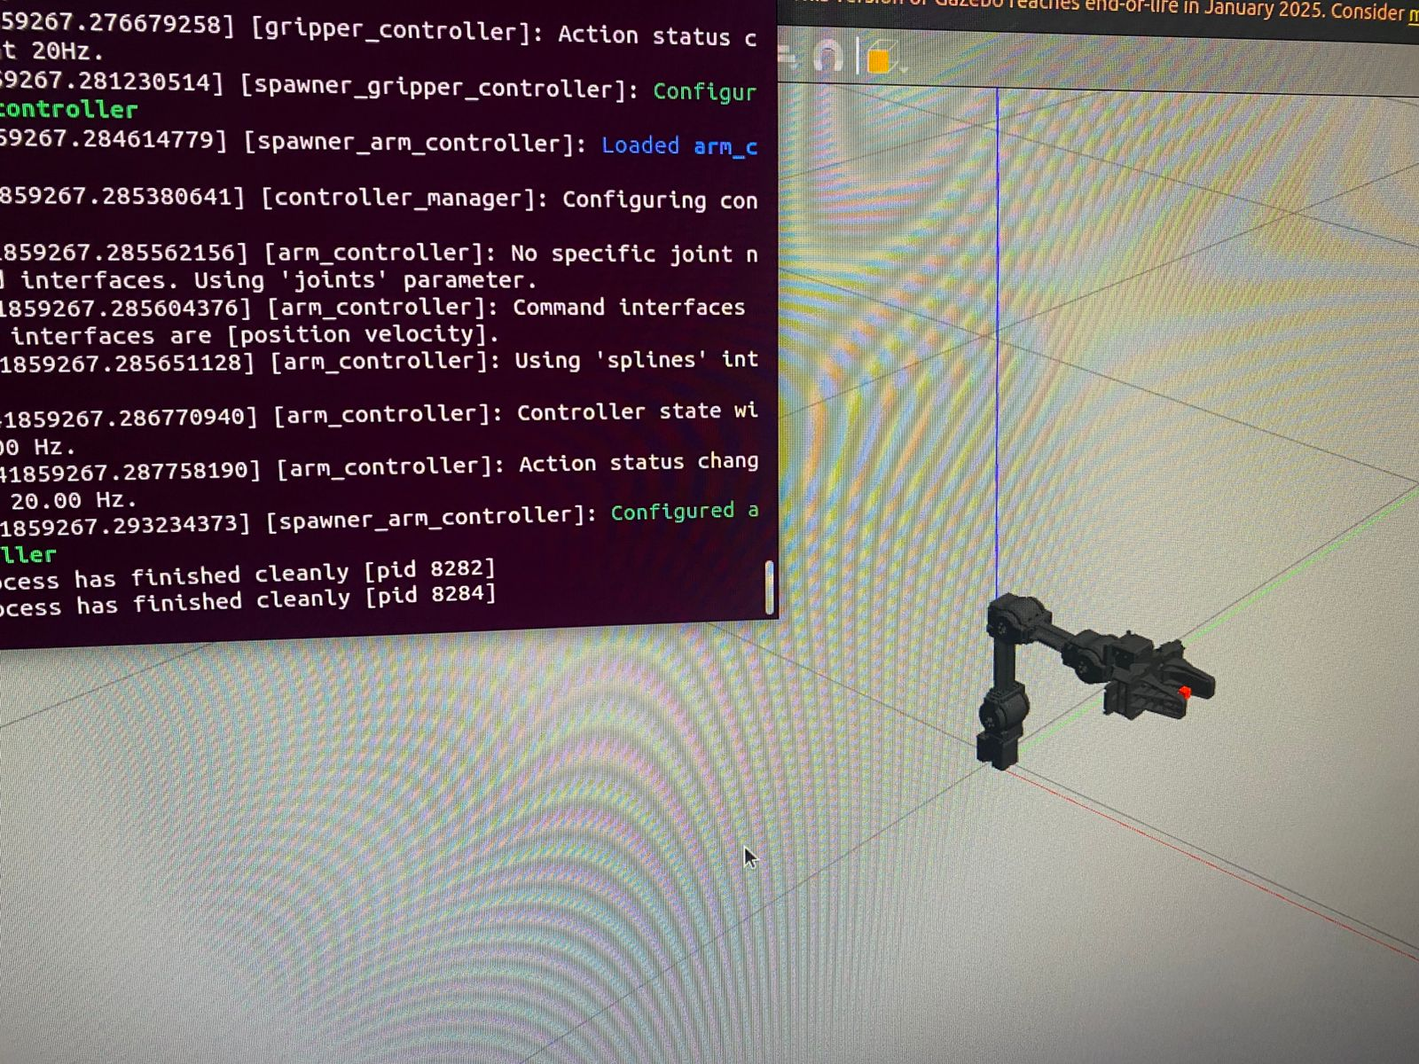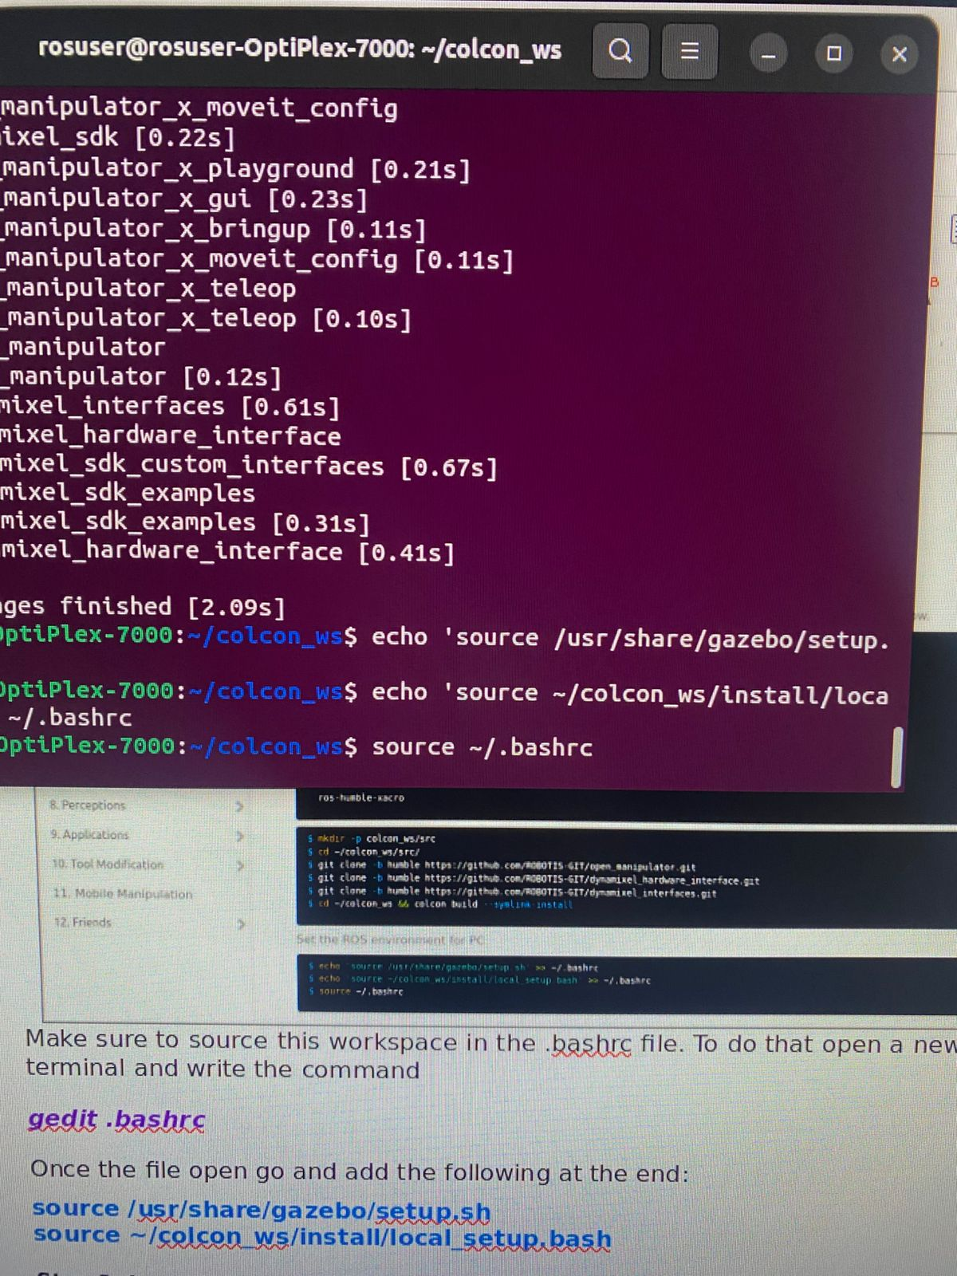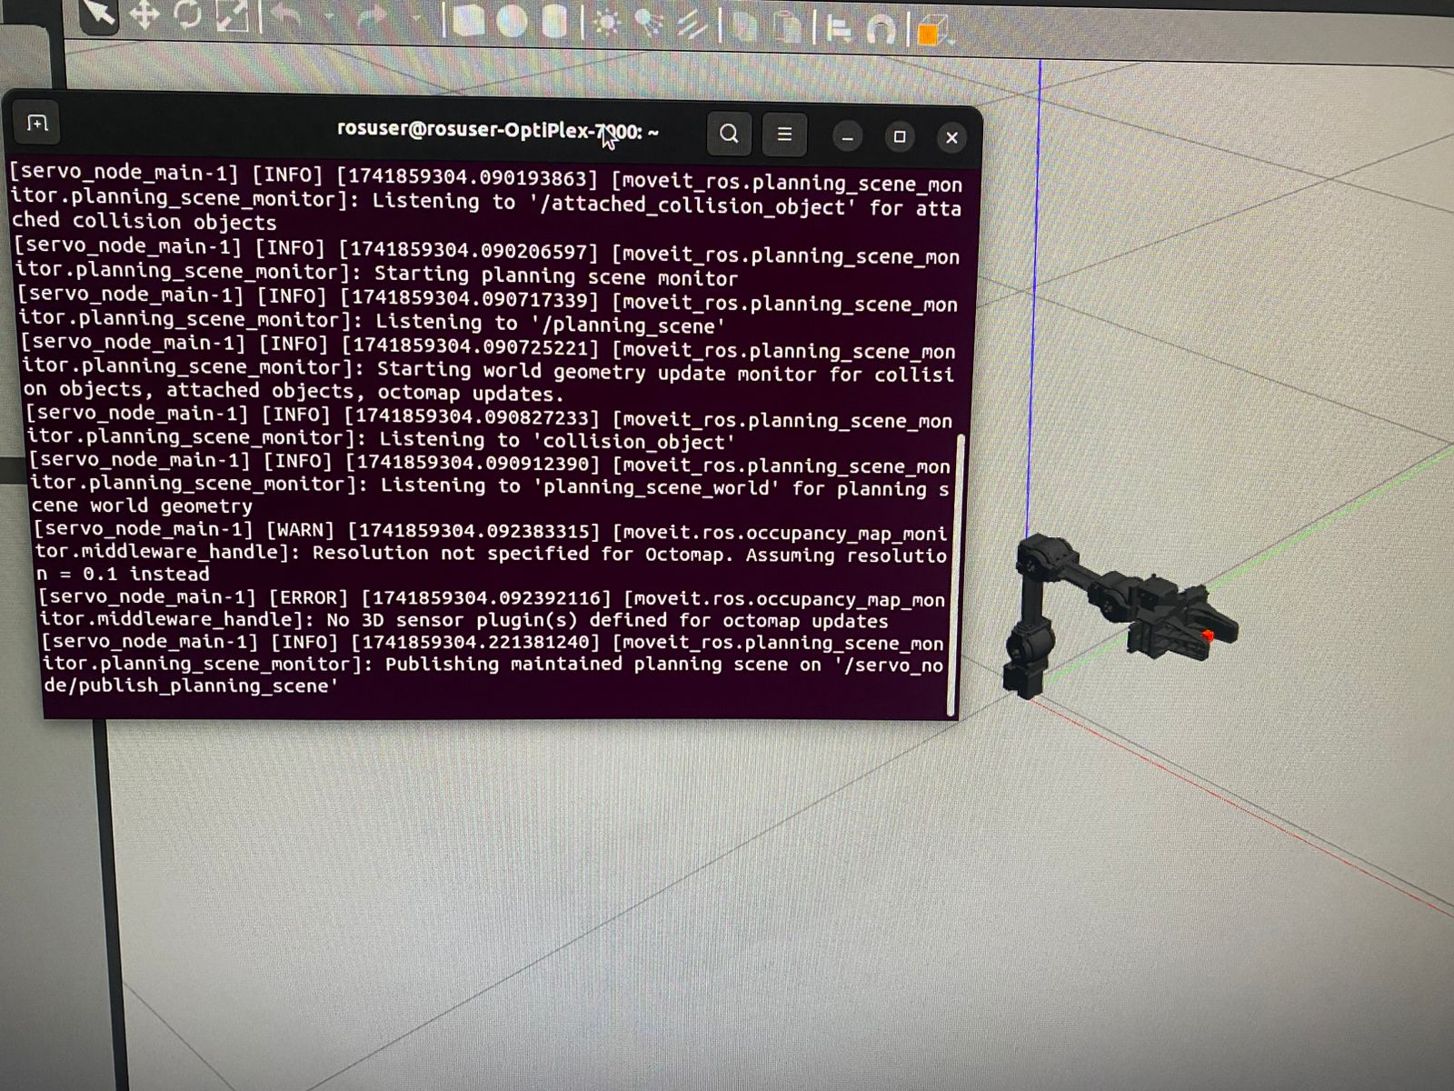

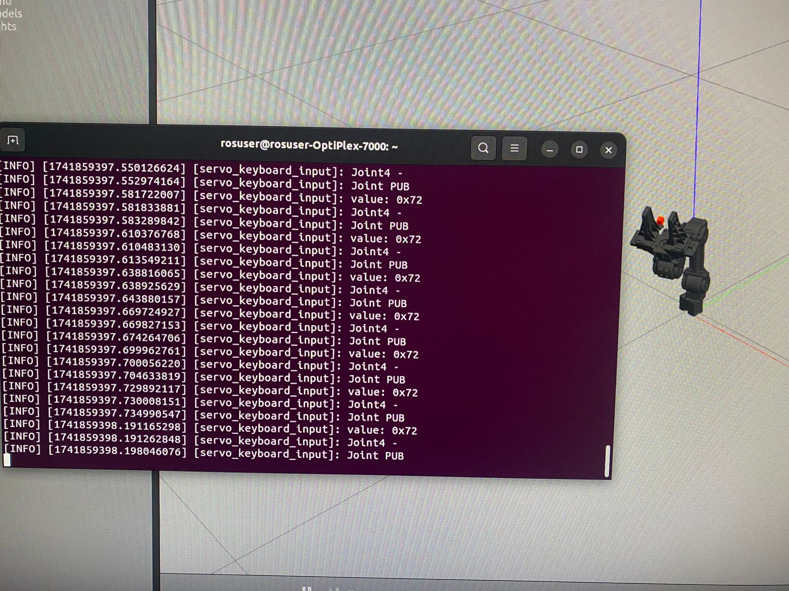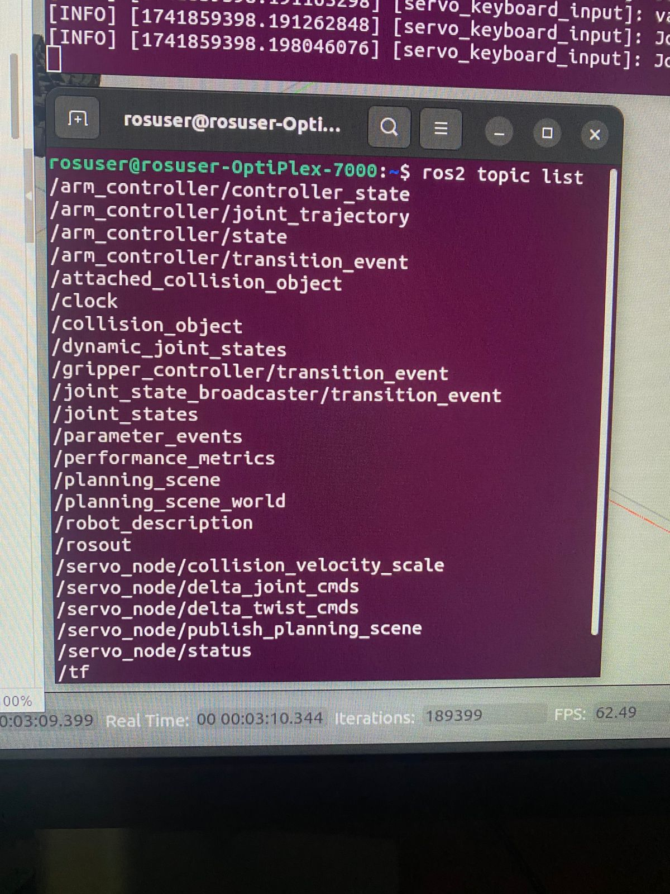

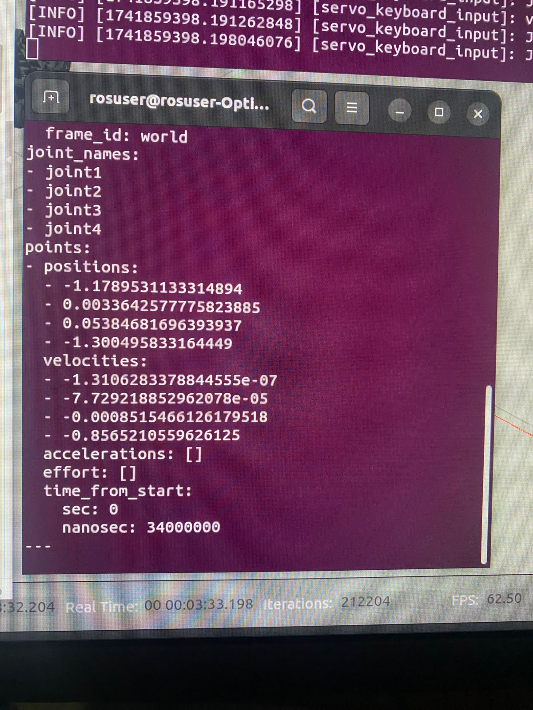

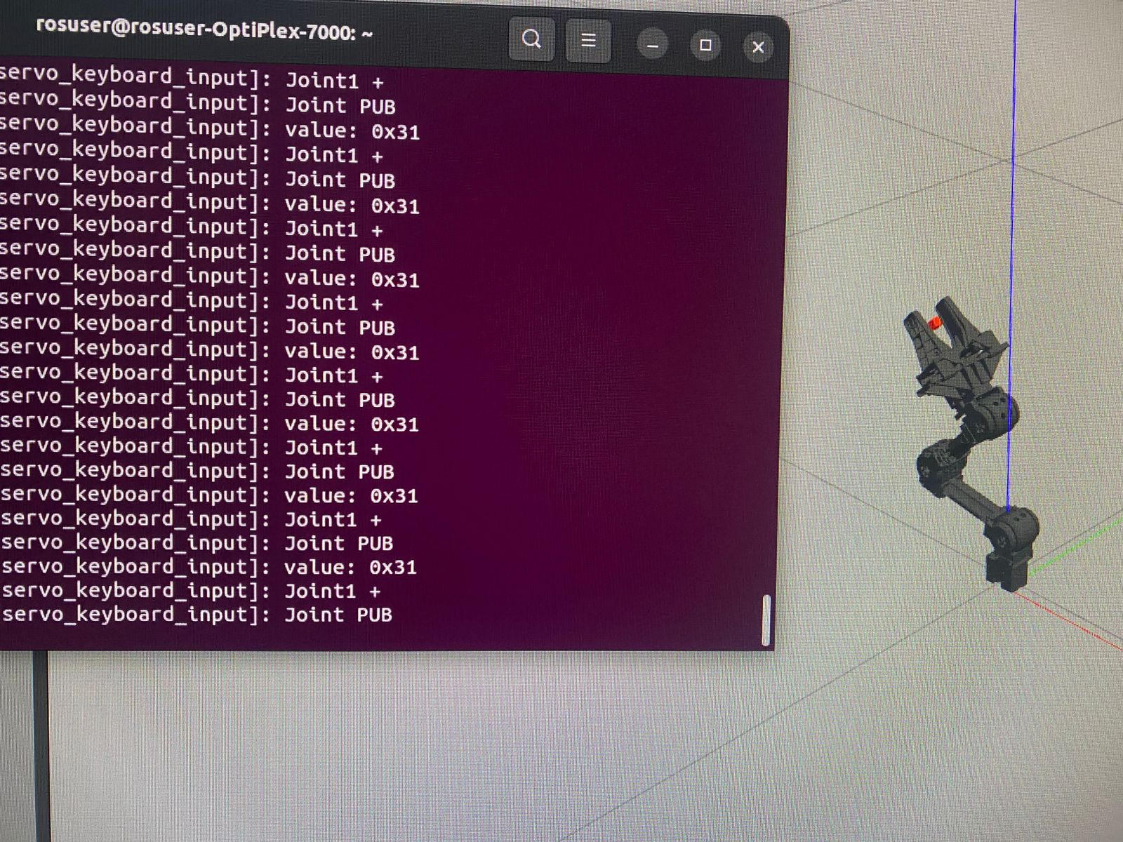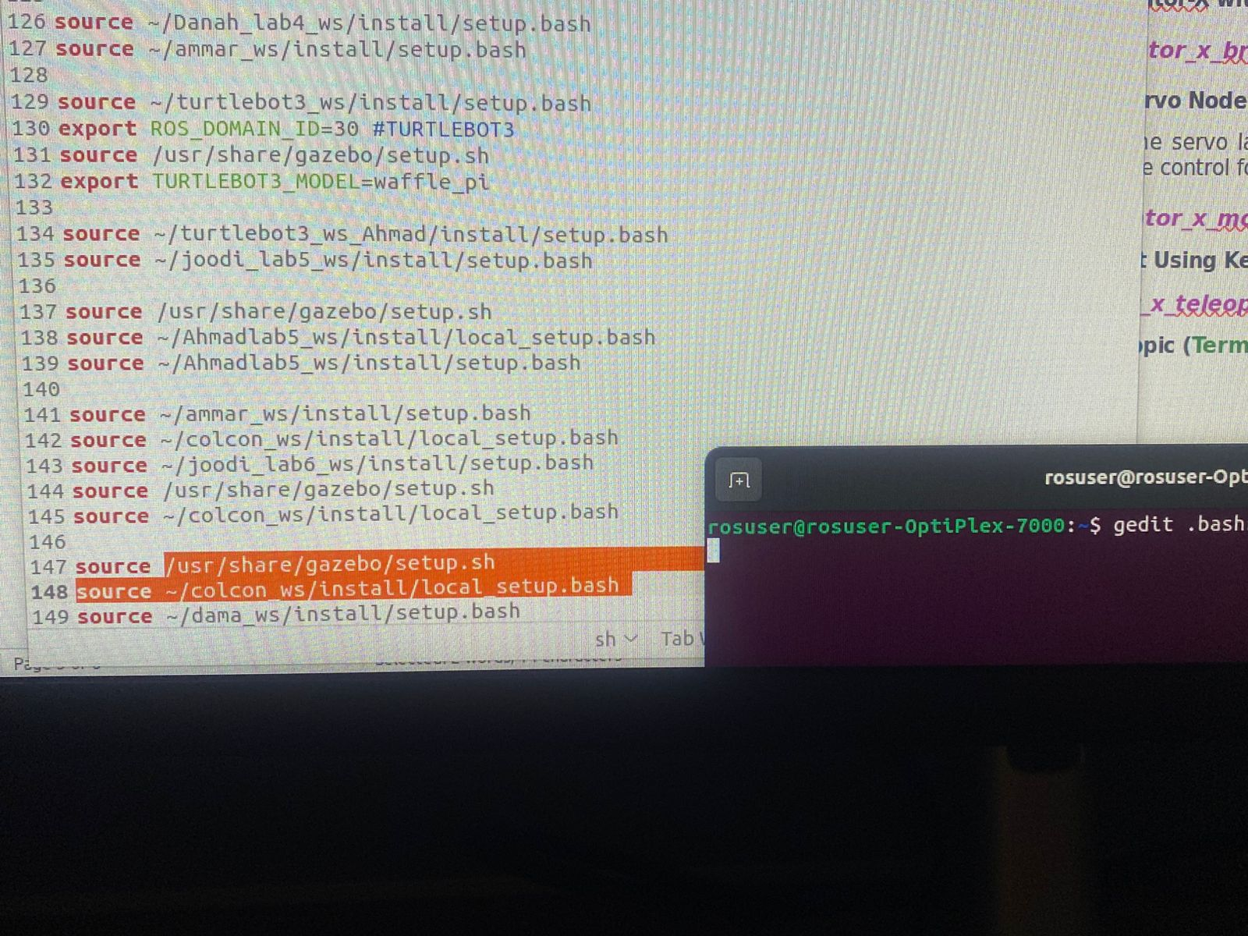

* **Exercise 2: Controlling OpenManipulator-X with Python**

To control the robot using Python, we need to understand the topic to which we will publish our messages. The topic name is **/arm_controller/joint_trajectory.**

This topic is responsible for controlling the robot's joints by sending trajectory commands, which define the desired positions, velocities, and other parameters for the joints over time.

The data published to this topic follows the format of the **trajectory_msgs/msg/JointTrajectory** message type, which includes:

1. **joint_names:** An array of strings representing the names of the robot's active joints (e.g., ["joint_1", "joint_2", "joint_3", "joint_4"]).
2. **points:** An array of trajectory points, each describing:

* positions: Desired joint angles (or positions) at specific times.
* velocities: Desired joint velocities (optional).
* accelerations: Desired joint accelerations (optional).
* effort: Effort or force applied to the joints (optional).
* time_from_start: Time duration from the start of the trajectory to reach the target position.

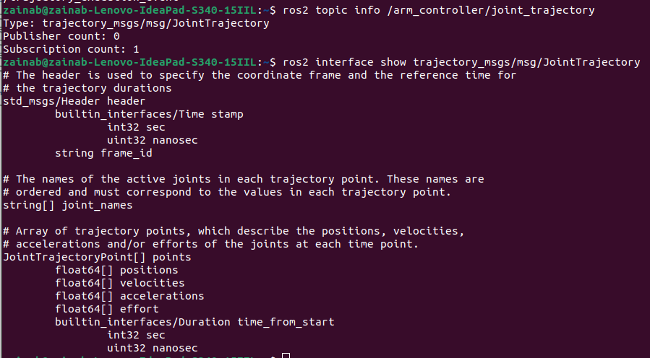

In this exercise, you'll create a ROS 2 package to control the arm using a Python script.

**Step 1: Create a New Workspace**

First, create a new workspace with your name (e.g., name_lab6_ws):

*mkdir -p ~/name_lab6_ws/src*

**Step 2: Create a New Package**

First, navigate to your ROS 2 workspace (e.g., name_lab6_ws) and create a package:

*cd ~/name_lab6_ws/src*

*ros2 pkg create --build-type ament_python arm_pkg --dependencies rclpy trajectory_msgs*

This creates a package named arm_pkg inside the src folder.

**Step 3: Write the Python Script**

Navigate to the package directory and create a move_manipulator.py script:

*cd ~/name_lab6_ws/src/arm_pkg/arm_pkg*

*gedit move_manipulator.py*

**After writing the following code**, for a quick run use the ***python3*** command (ensure you're in the same directory as the Python file). Additionally, make sure that Gazebo is already launched before executing the script.

***python3 move_manipulator***

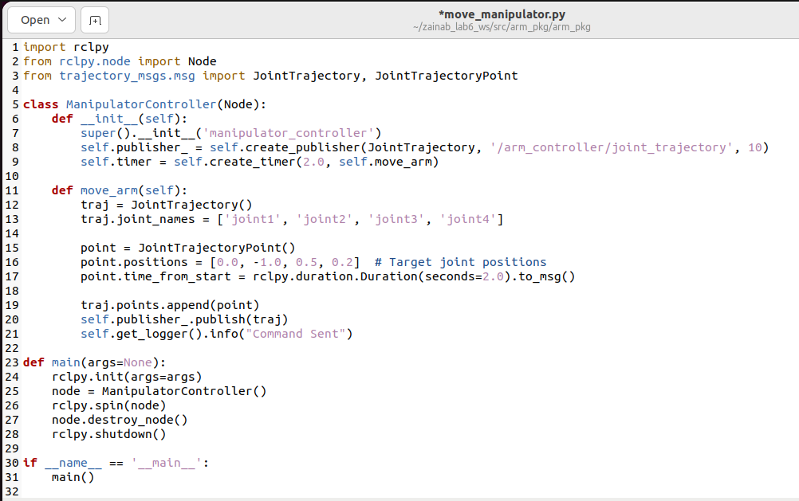

Once you've confirmed that the code is working, make it executable by running the following command (ensure you're in the same directory as the Python file).

***chmod +x move_manipulator.py***

**Step 4: Modify setup.py to Include the Script**

Open setup.py inside arm_pkg and add the entry point:

'move_manipulator = arm_pkg.move_manipulator:main',

**Step 5: Build the Package**

* Return to your workspace root and build the package:

*cd ~/name_lab6_ws*

*colcon build*

* Source the workspace in the. bashrc file:

source ~/name_lab6_ws/install/setup.bash

**Step 6: Run the Script**

First launch the Gazebo, and in another terminal run the python node

*ros2 run arm_pkg move_manipulator*

**Put screenshots of your work here (for ALL the steps):**

**move_arm**

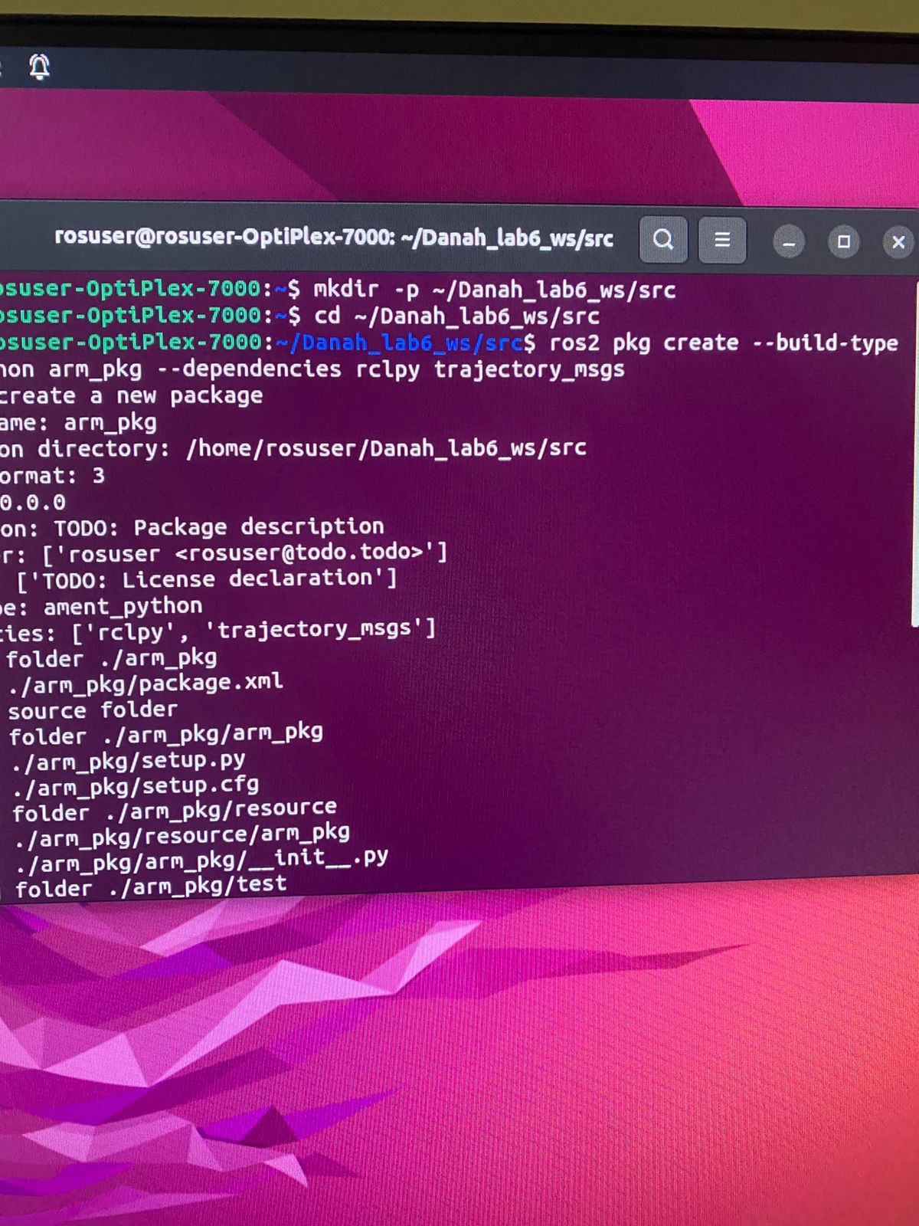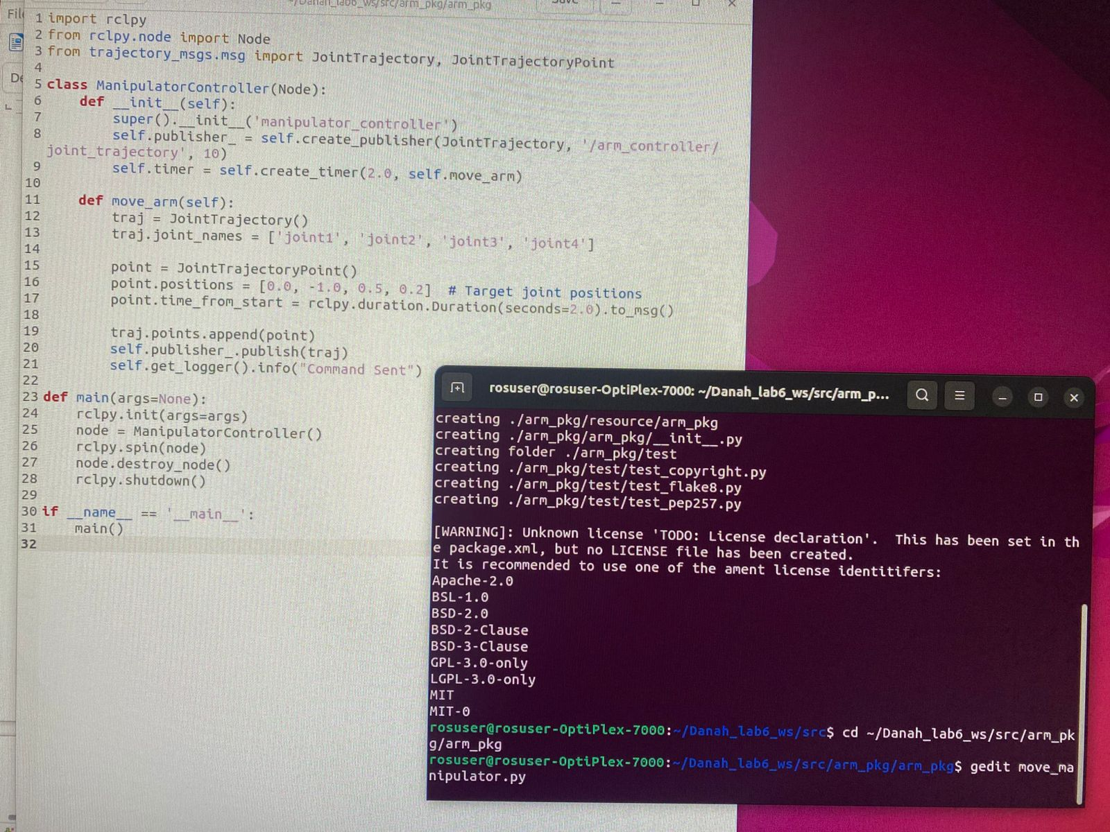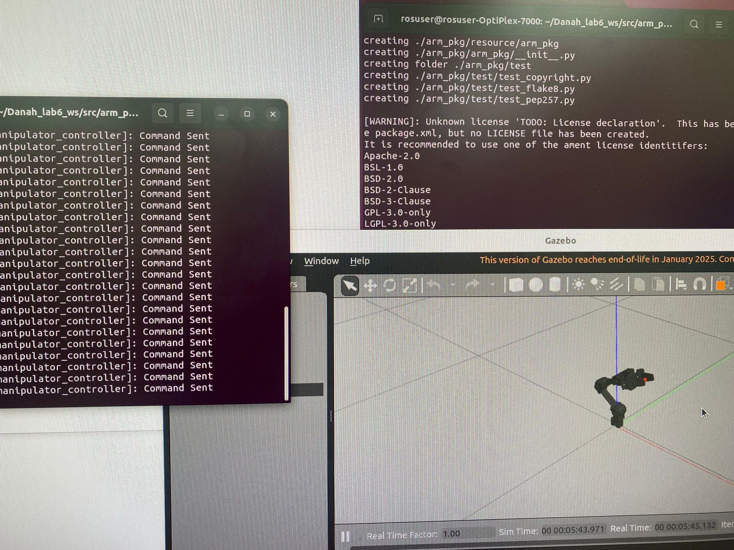

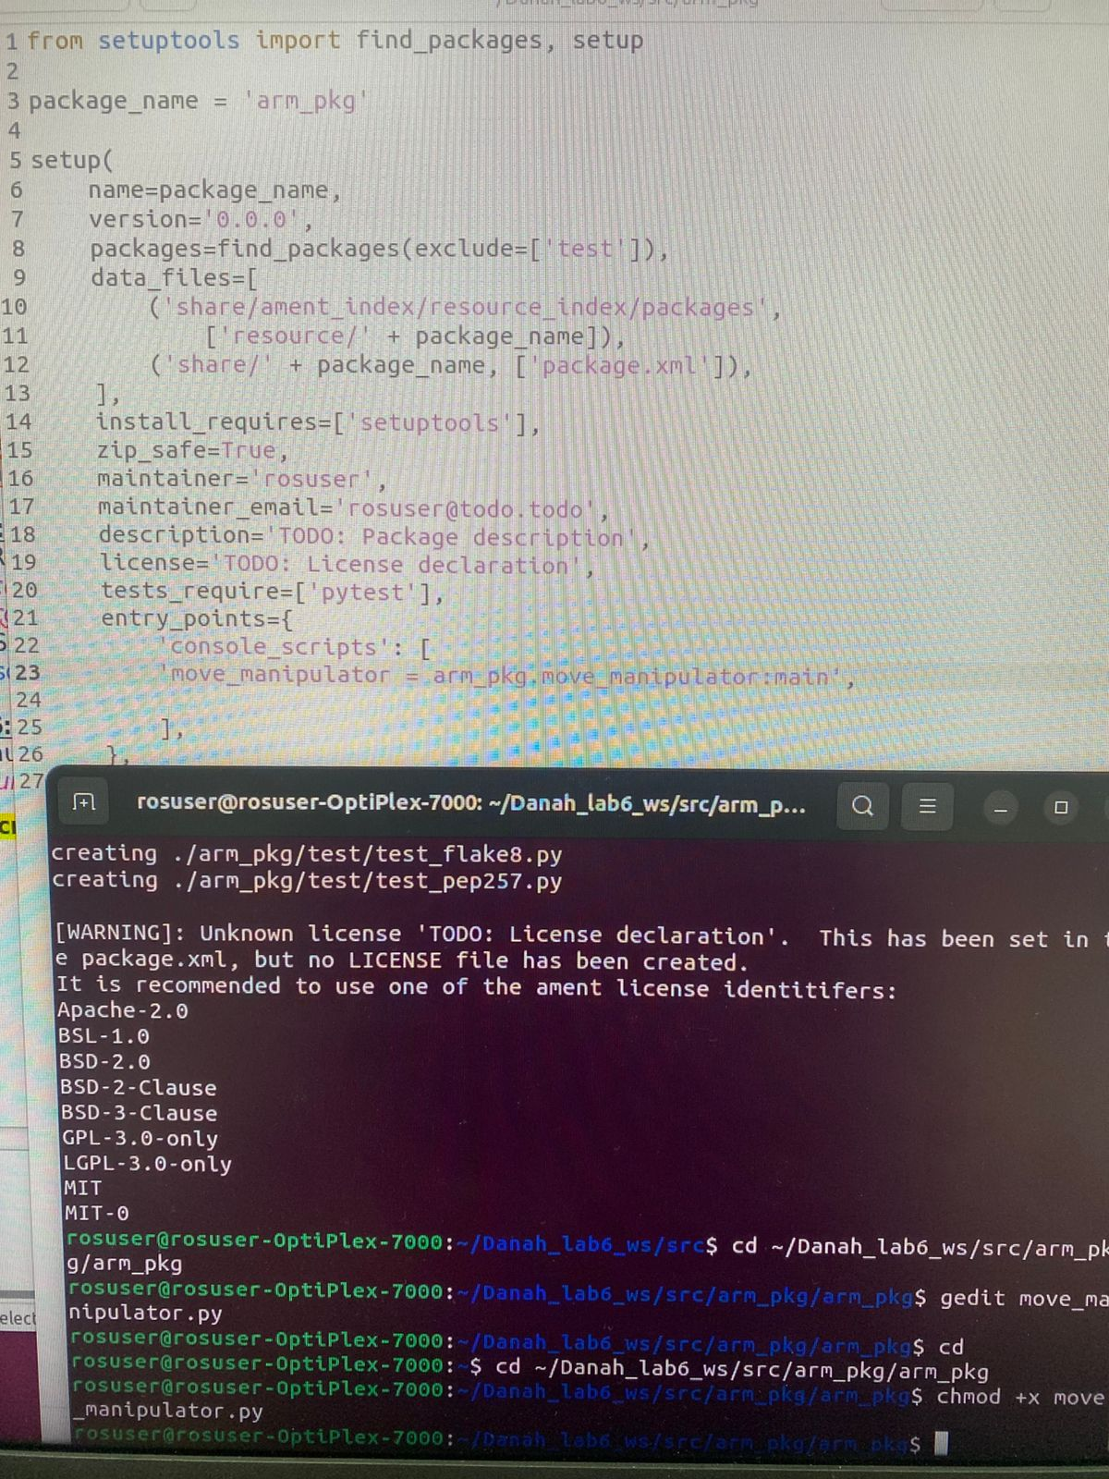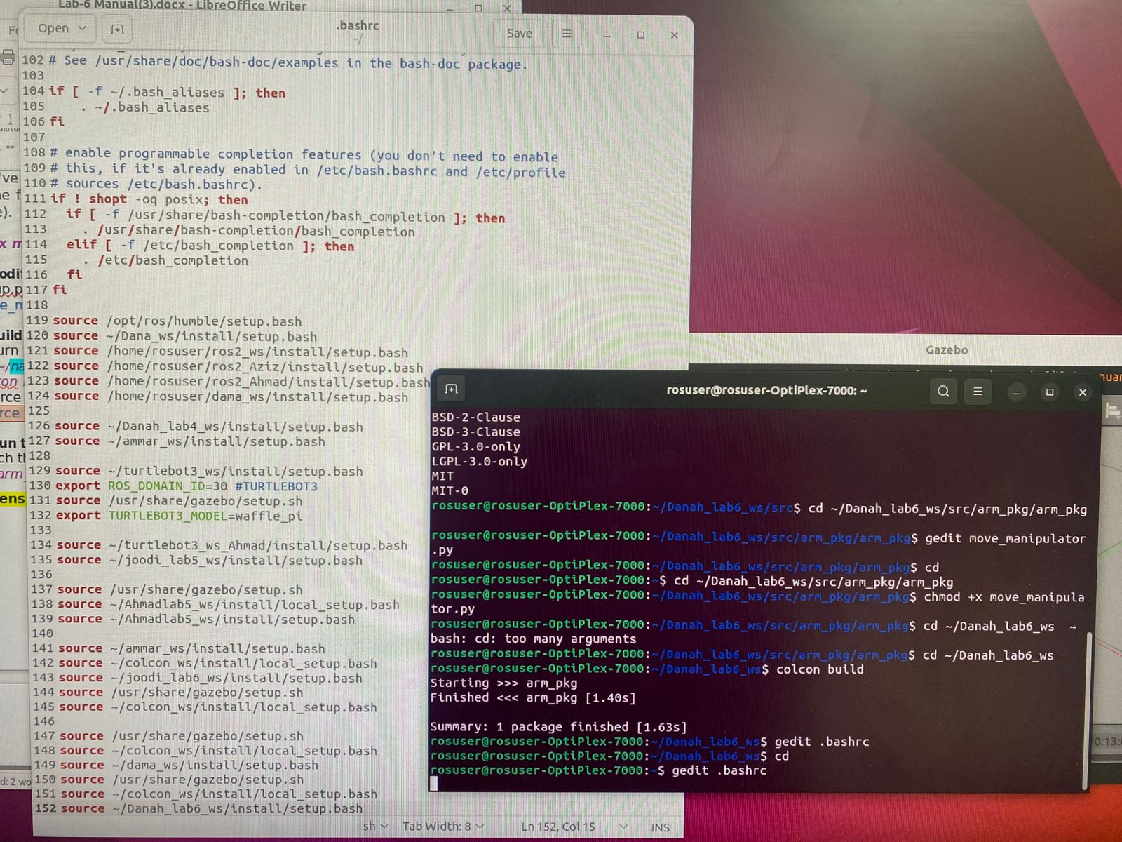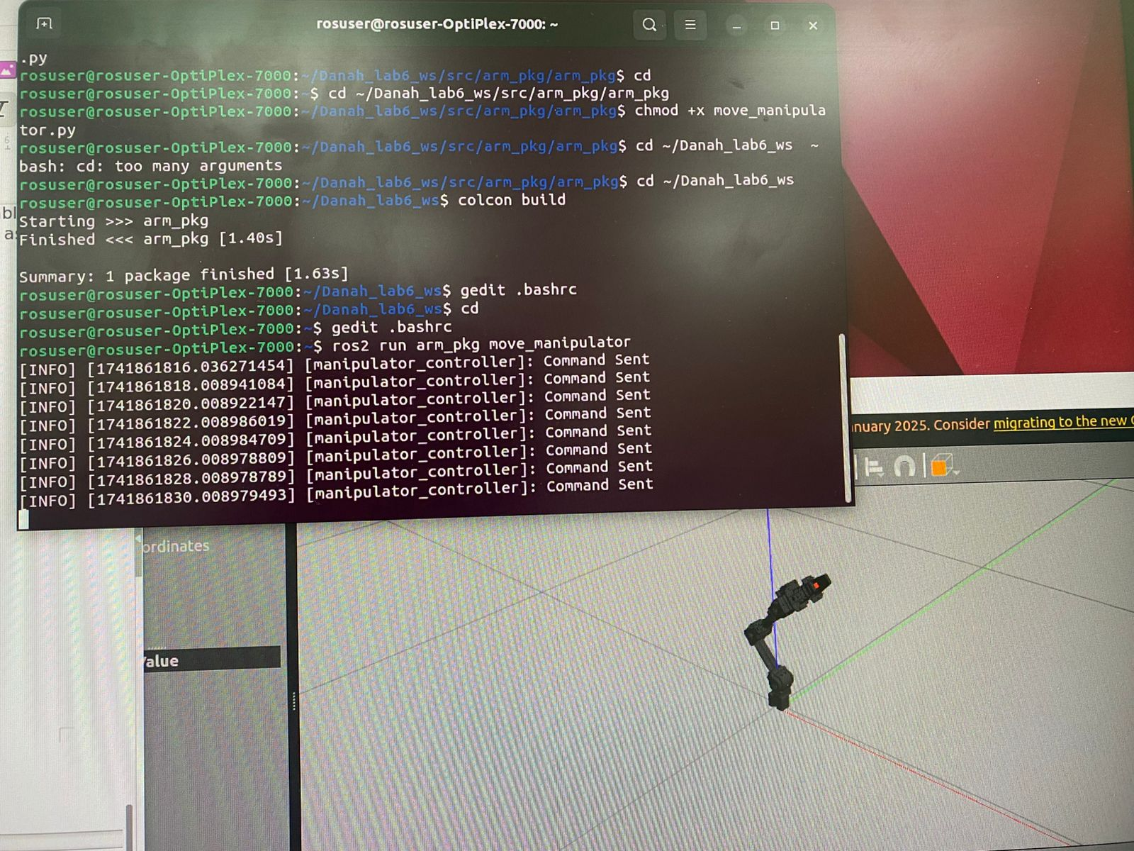

* **Lab activity:**

**Task1:** Modify the Python script from Exercise 2 to position OpenManipulator-X in a fully extended **upright stance** like the image *(hint: just edit the position values).* 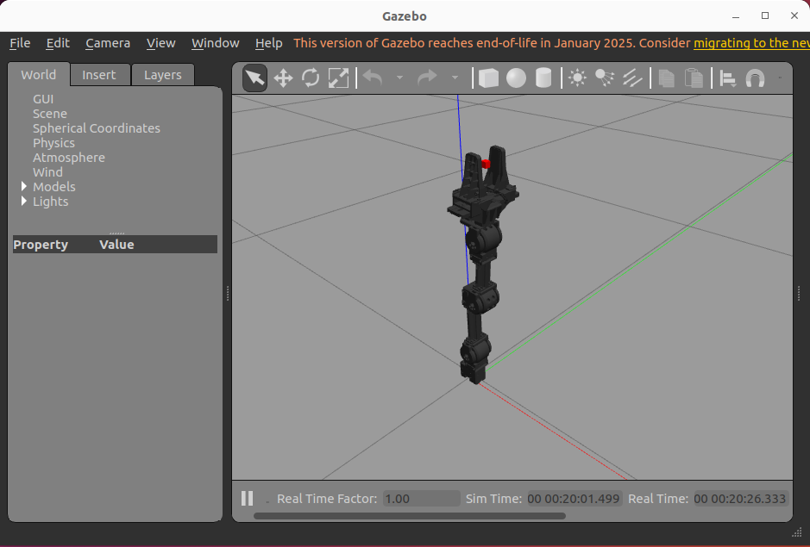

1. Provide the new values of the joint position (just the array):

[0.0, 0.0, -1.57, 0.0]

1. Explain what each value in the joint position array represents? And how does it affect the overall arm position?

the open manipulator-X consists of multiple segments connected by rotating joints, each joint position value influences the arm’s movement and orientation:

Joint 0 (Base): rotates the arm left and right

Joint 1 (Shoulder): moves the arm forward and backward, adjusting the gripper’s reach.

Joint 2 (Elbow): moves the arm up and down to control its height

Joint 3 (Wrist): rotates the gripper without changing its position

by defining joint angles within a coordinate system, the arm’s position in XYZ space can be precisely controlled, enabling tasks like picking and placing objects

3. Provide screenshot of the terminal that’s running the code and the OpenManipulator-X gazebo window:

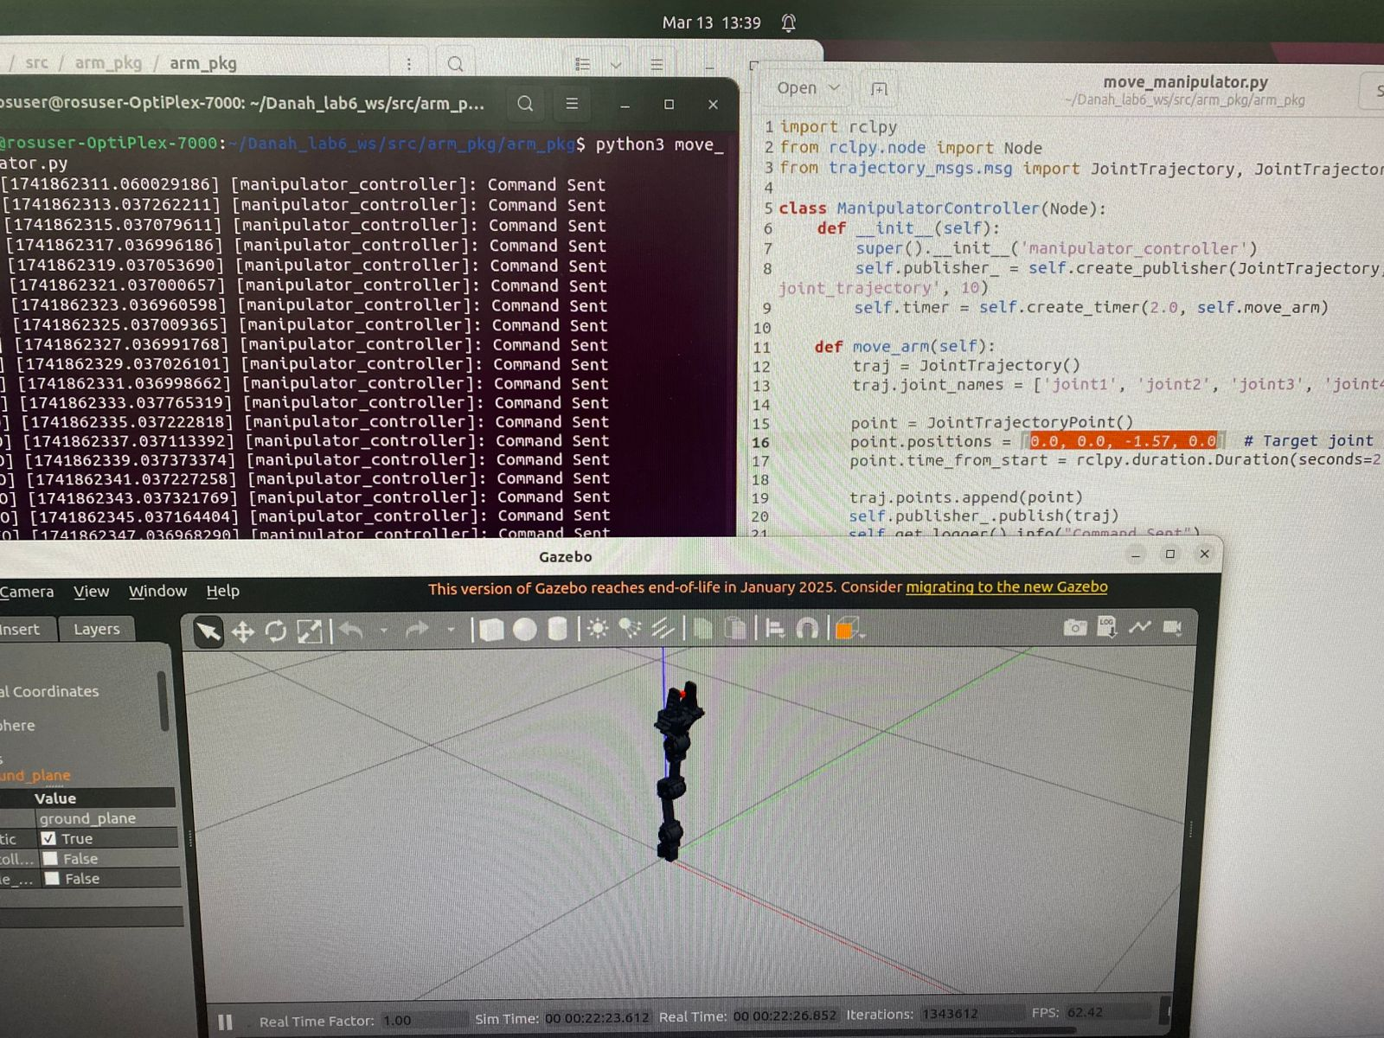

**References**

[**https://emanual.robotis.com/docs/en/platform/openmanipulator_x/overview/**](https://emanual.robotis.com/docs/en/platform/openmanipulator_x/overview/)